

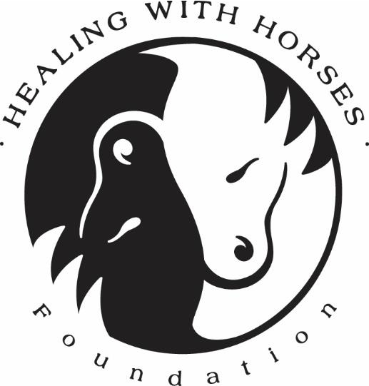
Healing with Horses Foundation 2017 Annual Report

ANNUAL REPORT 2017

OCTOBER 20, 2017 HEALING WITH HORSES FOUNDATION
#10-14 Galla Trace, Buccoo, Tobago

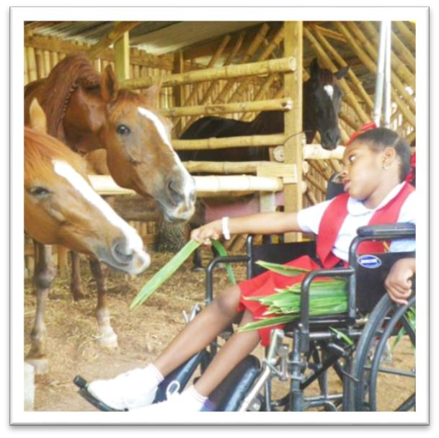
Mission Statement
Creating an integrated, inspiring space for differently abled children and adults, where they are embraced and empowered to realize their full potential through therapeutic interactions.

Vision Statement
“A Harmonious Wave of Healing for all”

Background
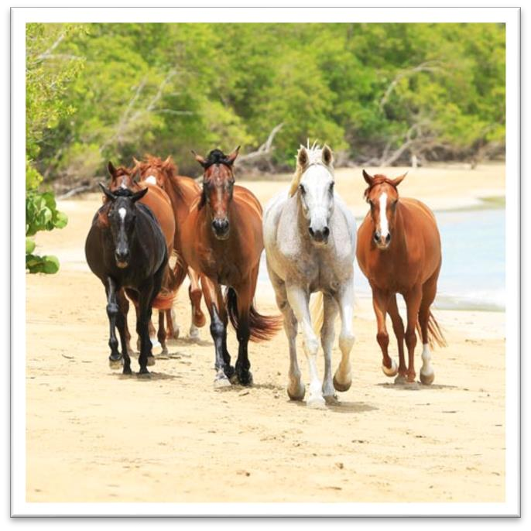
Healing with Horses was created in 2010 as a non-profit organisation realized from a dream by its Founder and Director, Veronika Danzer La-Fortune. With one horse rescued from the rain forest and a heart filled with love and hope, Mrs. Danzer La-
Fortune and her husband, Lennon created a place for children (from different backgrounds and nationalities and with varied physical and mental abilities) and adults, to come together and enjoy therapy and creative play.

We offer our services to various schools and organisations to attend free of charge. Our weekly sessions include therapeutic play in our Magical Playground, music, drumming, nature walks, gardening, arts and crafts and the exceptional experience of Being with Horses.

We have a healthy herd of 9 horses and 2 ponies (most rescued or donated) which gives the children a way to experience a strong sense of bonding and affection, along with the physical benefits of strengthening and improved balance from
horseback riding. Each child is offered the opportunity to ride, groom, feed and commune with these gentle animals.

1

Table of Contents
Mission Statement ..................................................................................................................................1

Vision Statement.....................................................................................................................................1 Background.............................................................................................................................................1 Board of Directors ...................................................................................................................................4 Staff ........................................................................................................................................................6 Volunteers.............................................................................................................................................10 HWH Trinidad Volunteers......................................................................................................................11 And special thanks to...........................................................................................................11 ..............................................................................................................................................................12 Students and Programs .........................................................................................................................13 Activities throughout Year.....................................................................................................................14 Fundraising throughout Year .................................................................................................................15 Articles..................................................................................................................................................17 In-Kind Donations..................................................................................................................................17 Challenges and Risks..............................................................................................................................19 How can you help?................................................................................................................................20 As a Volunteer...................................................................................................................................20 As a Donor or Sponsor.......................................................................................................................20 Future Plans..........................................................................................................................................21 For Additional Reading .........................................................................................................................21 Financial Statements 2017.....................................................................................................................22 Statement of Financial Position for the year ended 31st December ....................................................22 Statement of Activities and Changer in Net assets for the year ended 31st December 2016................23 Statement of Cash Flow for the year ended 31st December 2016.......................................................24 Addendum A .........................................................................................................................................25 Timetable for Ongoing After School Sessions.....................................................................................25 Addendum B .........................................................................................................................................26 Calendar of Events 2016........................................................................................................................26 September 2016................................................................................................................................26 October 2016 ....................................................................................................................................26 November 2016.................................................................................................................................26 December 2016.................................................................................................................................26

2

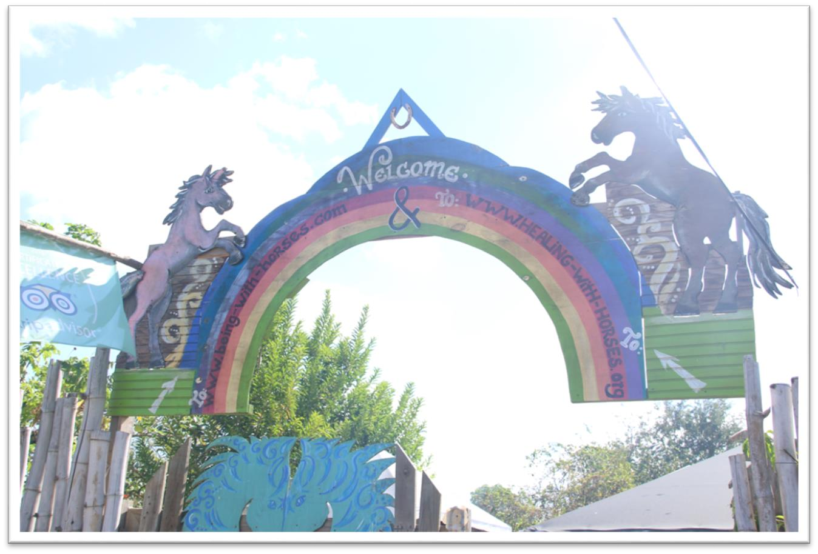
January 2017.....................................................................................................................................26 February 2017 ...................................................................................................................................27 March 2017.......................................................................................................................................27 April 2017..........................................................................................................................................27 May 2017 ..........................................................................................................................................27 June 2017..........................................................................................................................................28 July 2017 ...........................................................................................................................................28 August 2017 ......................................................................................................................................28 September 2017................................................................................................................................29 October 2017 ....................................................................................................................................29 Addendum C .........................................................................................................................................30 In-Kind Donations September 2016 to September 2017.....................................................................30

3

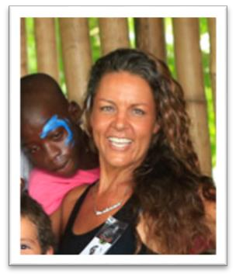
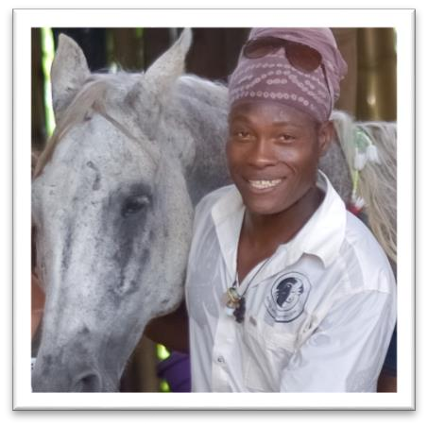
Board of Directors

Veronika Danzer-La Fortune

Founder | Director

Equine Therapist

Lennon La Fortune Founder | Director Equine Therapist

4

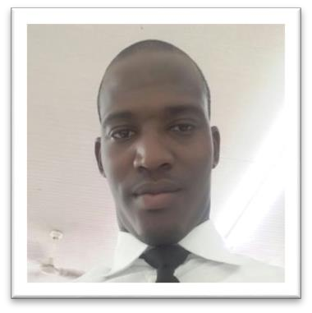
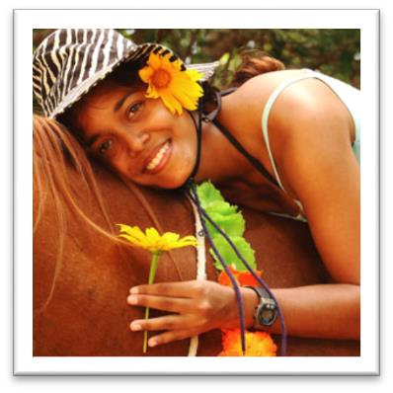

Arendell Brewster

Creative Director | Director

Dr. Leah A. Pouchet Veterinarian | Director

5

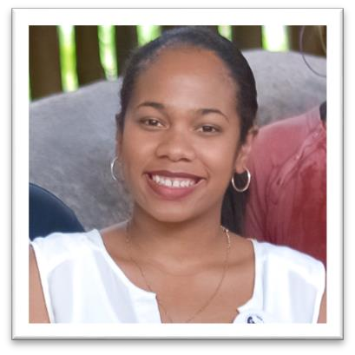

Staff

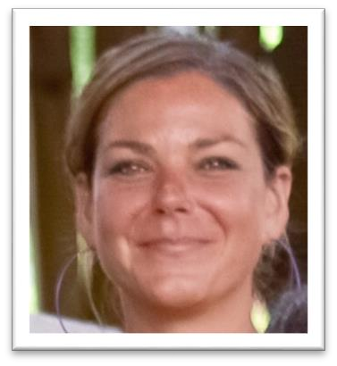
Kristy Leber Hostess | ENT Instructor

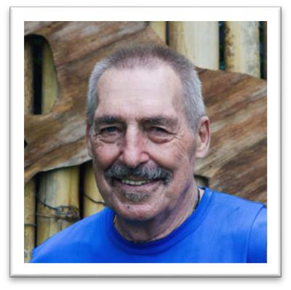
Juergen Rauch Park Manager

Sarah Vilain
Office Manager | Administrator

6

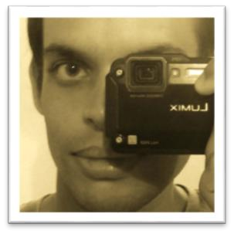
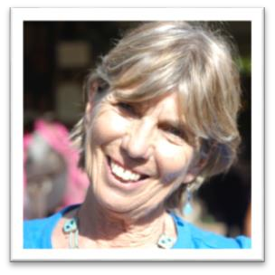


Daniel Brimacombe Assistant | Digital Media Editor

Marjorie Linglet International Liaison

Line Dobrowen

Virtual Event Coordinator

7

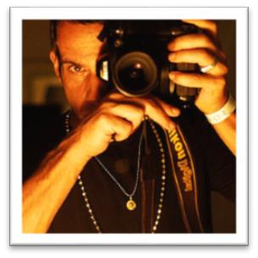
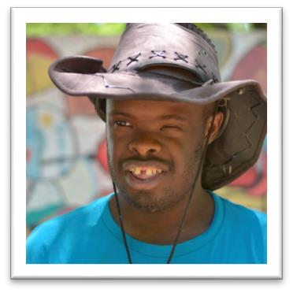
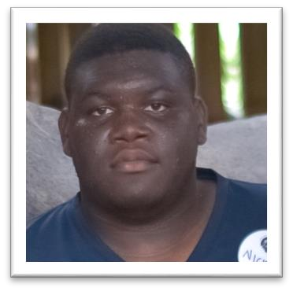

Bernhard Rossmann Online Development

Nickson Rougier HWH Paddock maintainer| Chef

Keron McLetchie

Paddock Maintenance

8

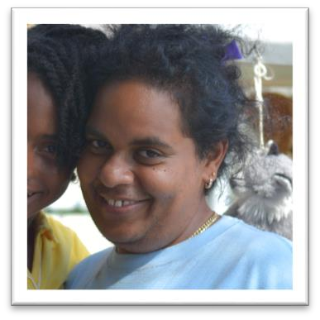
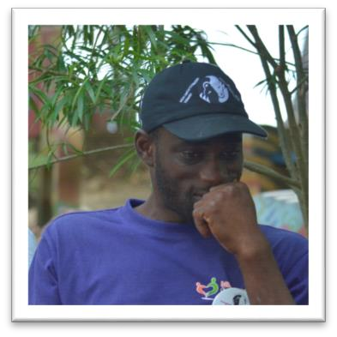
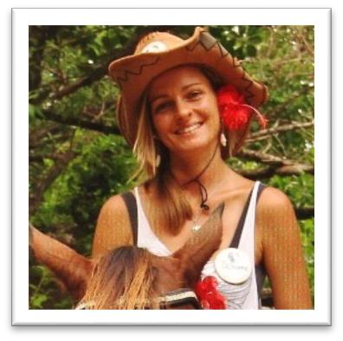
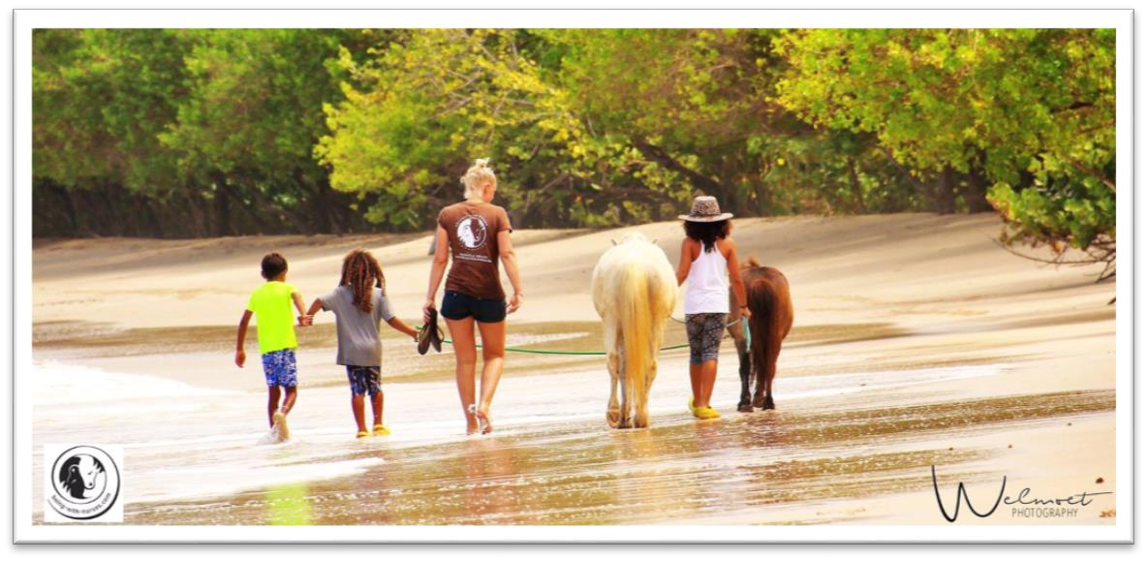

Jayon Brathwaite

Park Assistant
Anna-Maria Pallai

Camp Coordinator | Volunteer Coordinator

(3 Months)

Susanne Hirschmann Child Supervision

Sunna Bohmers Child Supervision
(Photograph by Welmoet Photography)

9

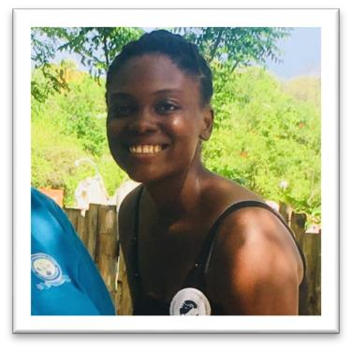
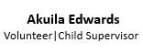
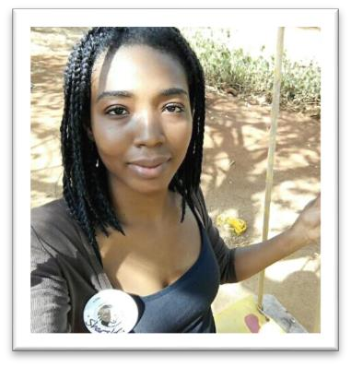
Volunteers

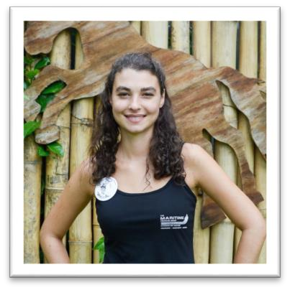
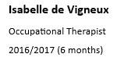
Gem Sonia Sarabo

Noema Mahler

Laura Conigiello

Sandra Hertz

Hannah Brunttum

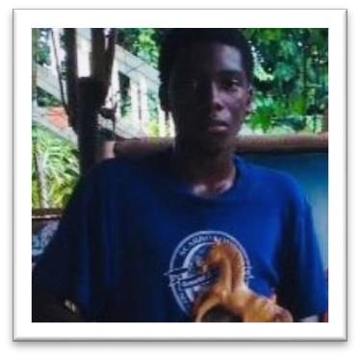
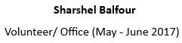
Noel Juarez Ramirez

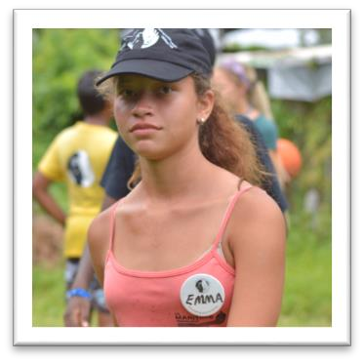
Romanie Dial Lena Kayser

Florenica Solomon

Sophie Sorensen

Jabari Arnold Fie Jorgensen

Emma Knott

*A special thanks to all our volunteers who we could not mention, but could not do without during this year. Your hard work, special talents, caring natures, unwavering patience, kindness, respect and most all your time and effort you put into this foundation is much appreciated. Though it has been a lot of work, your support and engagement is what made a difference to the foundation. We look forward continuous support.

10

HWH Trinidad Volunteers

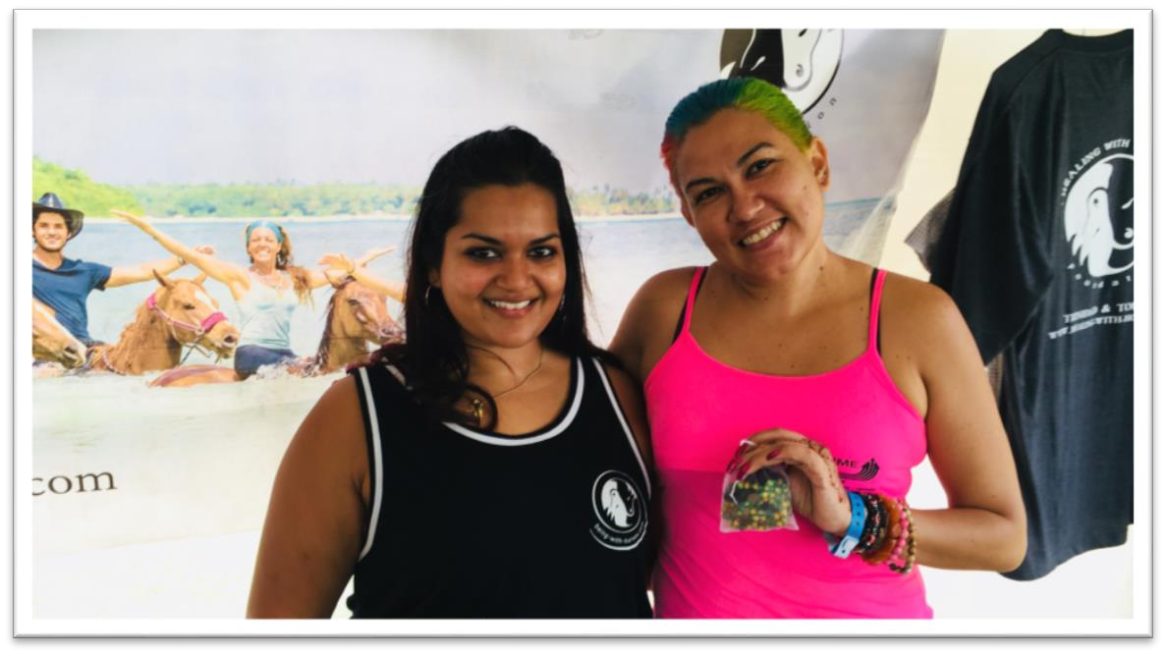
Occupational Therapist, Anastasia Raquel Martinez and Yoga teacher, Michelle Foreman

And special thanks to...

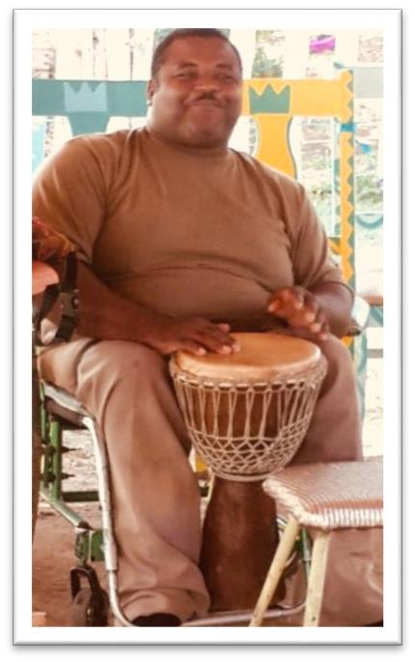
Mr. Jason Clarke

( Music teacher HWH’s camp )

11

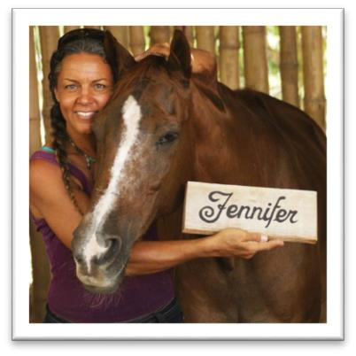
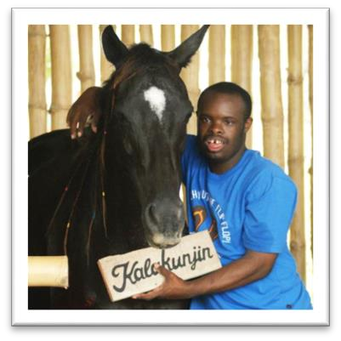
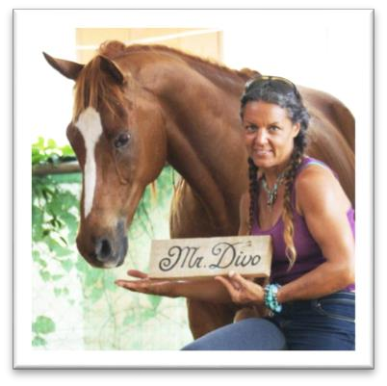
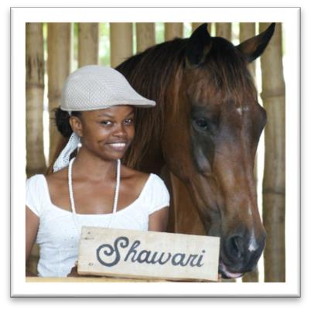
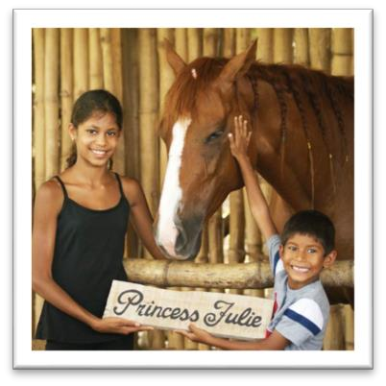
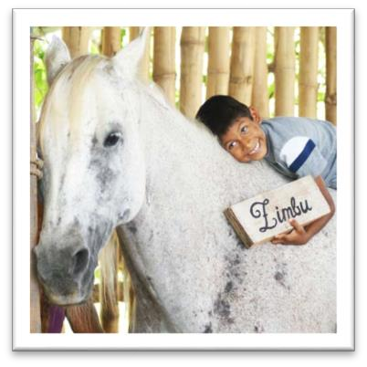
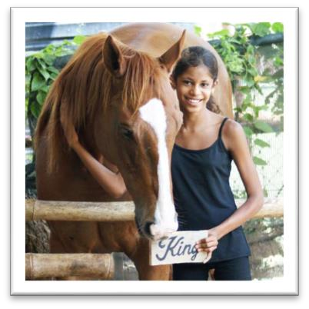
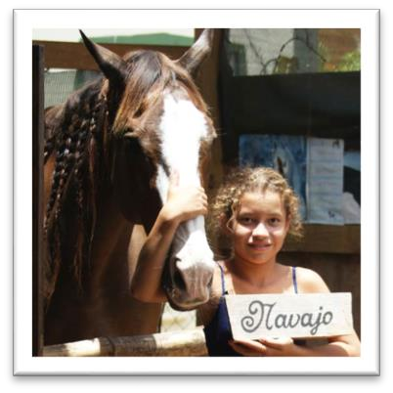
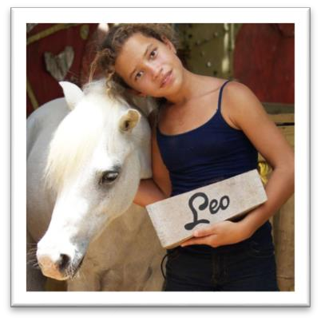
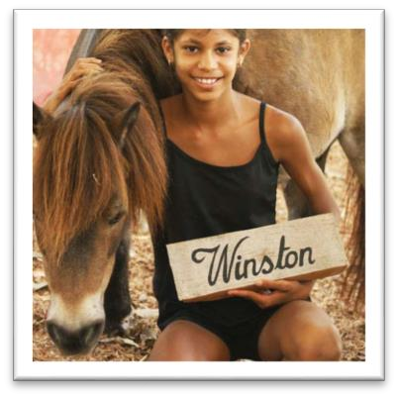
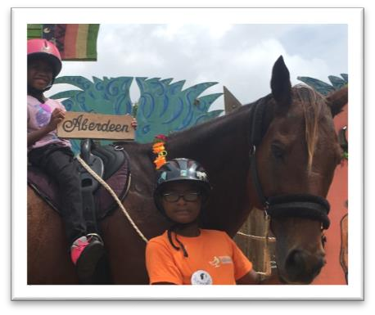
THE HERD:

12

Students and Programs

We offer Equine Nature Therapy to our students who are differently abled. We have an ongoing Afterschool Program which is offered to the following institutions weekly from Monday to Saturday:

Yahweh Foundation
Technical Vocational School Private Students

Many of our participants have been diagnosed as follows: ADHA, Down syndrome, Cerebral Palsy, Autistic, Hearing and Visually Impaired. The participants are guided by teachers and volunteers and encouraged to be creative and expressive. They also enjoy the outdoors, being surrounded by nature and the sea. These unique sessions allow the children to improve their physical strength and overall well-being, along with gaining new insight, improving self-esteem and realizing unknown talents.

HWH’s main program consists of ongoing afterschool Sessions which are offered throughout the year to various school groups and private organizations, such as the Yahweh Foundation and the Technical Vocational School. The focus is” Being with Horses” as the children commune, groom, feed, and ride. Our Therapeutic Playground offers a variety of stations for swinging, climbing, seesawing, imagination, and creativity. Please refer to ‘Addendum A’ for the ongoing Afterschool sessions.

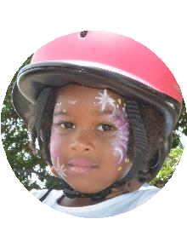

There is also a three-week Summer Camp which caters to children aged 6-12, with different levels of abilities and varying backgrounds. They are primarily local but we include international children. The Camp offers 4 activities daily, with a few special events scattered throughout the weeks. The camp is supported by a core of 16 instructors and 11 volunteers both local and from abroad. Our intention is to offer a wide variety of experiences in which each child can experience their own level of participation dependent upon their physical abilities and social capacity.

• Being with Horses Session • Nature Walks
• Creative Gardening • Arts & Crafts
• Outdoor Exercises • Yoga Sessions

Afterschool Session
• Being with Horses
• Swimming with Horses • Love in a Lunch Box • Creative Gardening • Capoeira Dance • Arts & Craft
• Music & Drumming
• Nature Walks & Yoga on the Beach

Summer Camp

13

Activities throughout Year

We participated in many local events to raise funds and awareness for the foundation. These events included the 92nd Annual Buccoo Goat and Crab Race Festival, Buccoo Heritage Festival, and Guardian Group’s Run for Fun Event. Our staff and volunteers also attended workshops and training courses to improve their skills, such as the PlayAble Introduction to Para Sport course, and the Social Solutions’ NGO Social Media Marketing and Management & NGO Accounting 101 workshop.

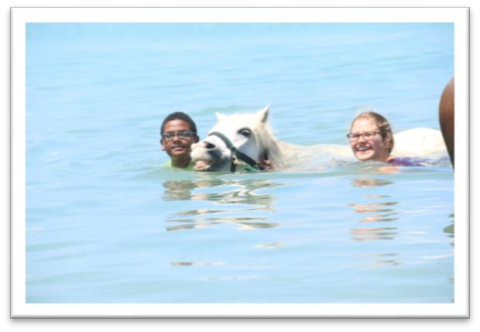
The 2017 Integrated Summer Camp was held from July 10th – July 28th, 2017 at the Healing with Horses Park in Buccoo, Tobago. From 9:00 am to 3:00 pm, Monday through Friday, the children were divided into small groups, each facilitated by a teacher and two group leaders. The children enjoyed music, dance, sports, acting, arts and crafts, creative gardening, nature walks, yoga, face painting, and the unique experience of being with horses.

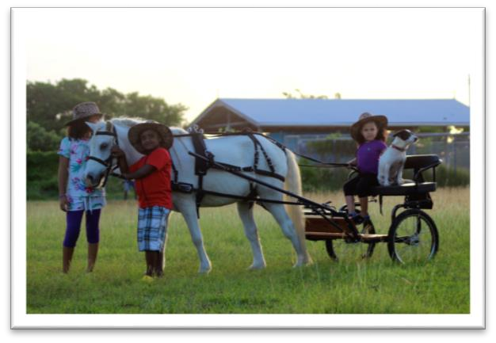
Fifteen volunteers, including occupational therapists Gem Sonia Sarabo and Anastasia Raquel Martinez, donated their time to conduct sessions and activities with the children. We had a Camp doctor on call as well as first-aid assistance on site. The children and
volunteers were provided with water and snacks daily, and were given HWH T-shirts, bags and water bottles. We also had the House of Rest available for those children who needed it.

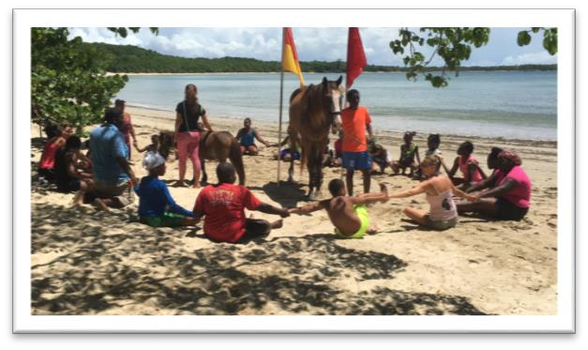
On the final day of Camp, the campers, volunteers and staff were honoured in a small celebration ceremony held in appreciation for their time with us.

Currently, there are two live-in volunteers from Germany, Isabelle de Vigneux and Lena Kayser. Both conduct hour-long therapeutic sessions with children every Monday - Saturday. Refer to Addendum B for ‘Calendar of Events 2016’.

14

Fundraising throughout Year
We have procured donations from public and private sectors through active fundraising: sending out proposals and grant requests, holding community-based fundraisers, and selling merchandise and acquiring donations from tourists and friends of Healing with Horses. We are also very active in the social and traditional media.

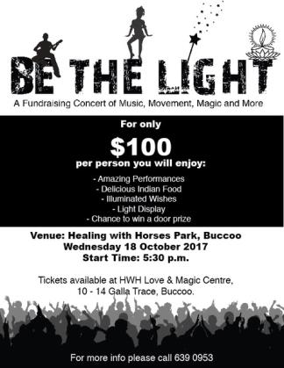
We are extremely resourceful, making use of donated and recycled materials, such as using sawdust for the horse bedding, building our own facility with bamboo cut from the bush, painting our own signs, building our own handicap bathroom, taking in rescued horses, doing our own vetting, searching out qualified supervisors to volunteer, and seeking out discounted housing for our volunteers from abroad.

We function largely on in-kind donations, purchase as little as possible, and are very conscious of the value of recycled goods. With sufficient funds, HWH would be able to provide ample stipends to our volunteers, and employ more therapists to assist with the children, thereby improving the quality of care and our ability to serve more children.

To raise funds for the Afterschool sessions we collected funds to make the 2017 calendar. The theme was “Equine Spirits”. It featured the following businesses:

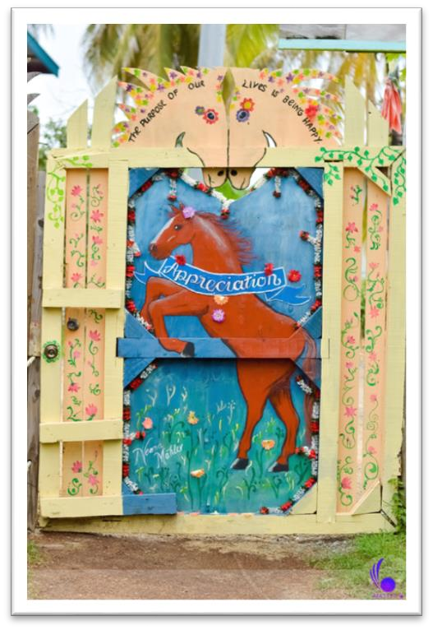
1. Central Bank of Trinidad & Tobago 2. Castara Retreats
3. Equilibrium Graphic Media 4. Everything Slight Pepper 5. First Citizens
6. Guardian Group
7. Ins & Outs of Trinidad and Tobago 8. Kariwak Village
9. Scrip-J
10. Seahorse Inn

Each business made a contribution of TT$ 3 000.00. Two thousand (2000) calendars printed. Some calendars were given to friends and supports of the foundation, the rest was sold in the Love and Magic Centre at TT$150.

Work for next year’s calendar (2018) began. Proposed theme ‘Appreciation’.

Many proposals and letters were sent to various businesses
and organisations to raise funds for the Ongoing Afterschool Session, and the 6th Annual Buccoo Integrated Summer Camp. We had many sponsors that answered our call, which we are eternally grateful for. These sponsored ranged from local companies to serval government ministries.

15

Ministry of Social Development and Family Services Massy Foundation
The Maritime Financial Group Nestle
MovieTowne
Magdalena Grand Beach and Golf Resort Blue Waters
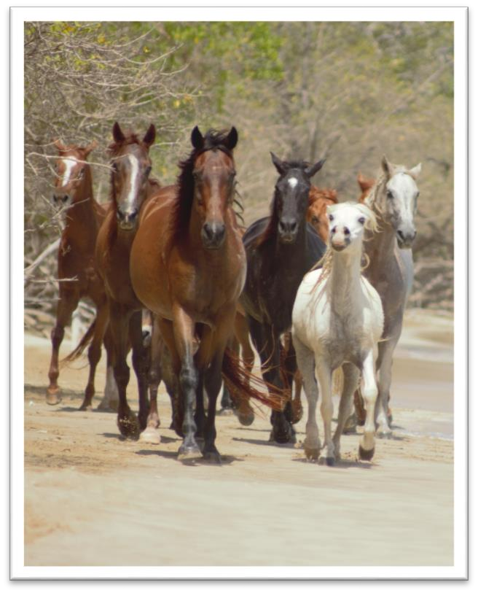
Atlantic LNG Scotiabank Colfire
ANSA McAL Sagicor
Colonial Fire & General Insurance Company Limited Moravian Church
LaTartaruga Restaurant Seahorse Inn
Shore Things Café Makara Restaurant Green Age Farms
Beyond Business Mode Alive
Eden Nurseries Edition Boisélle
Central Bank of Trinidad & Tobago Castara Retreats
Equilibrium Graphic Media Everything Slight Pepper
First Citizens
Guardian Group
Ins & Outs of Trinidad and Tobago Kariwak Village
Sangha Yoga Trinidad Scrip-J

16

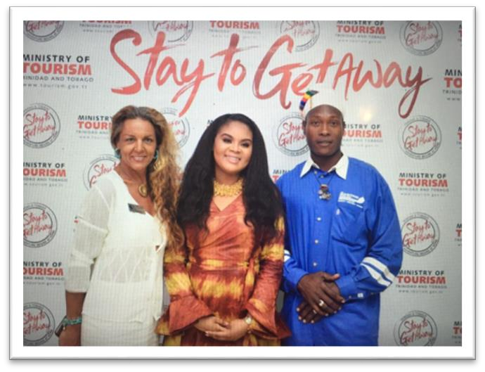
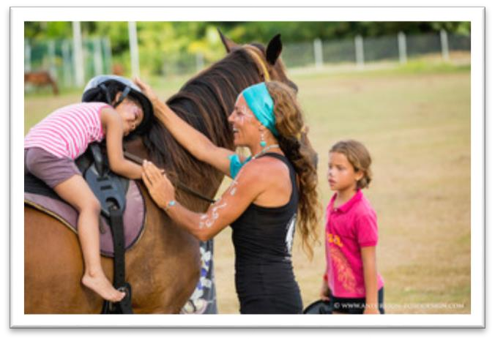
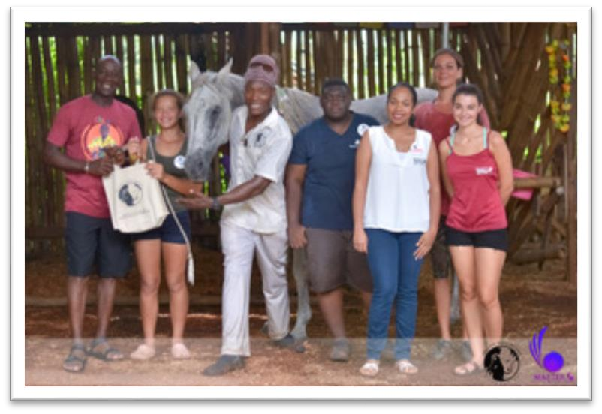
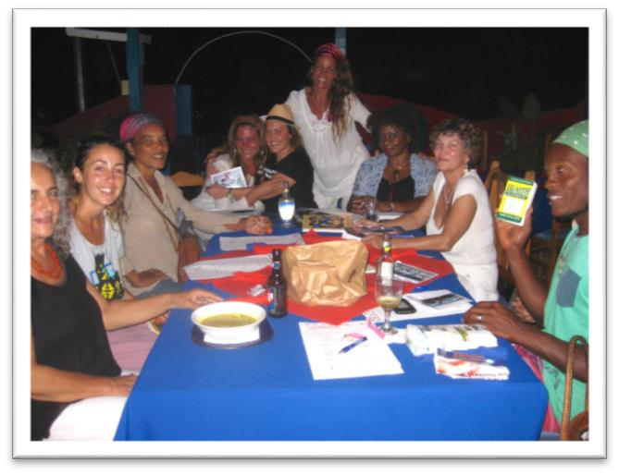
Articles
There were many newspaper, magazine and TV segments on the foundation. We are grateful to all these businesses for taking the time to be interested in our activities and publishing wonderful pieces. It has created awareness for our foundation as well as brought volunteers globally. Please see ‘Calendar of Events 2017’ for full listing.

In-Kind Donations
Throughout the year people have brought items and other gifts for the horses, children and foundation. These items include saddles, helmets, buckets of mangoes, books, clothes, and toys. Please see ‘Addendum C’ for a list of items donated.

17

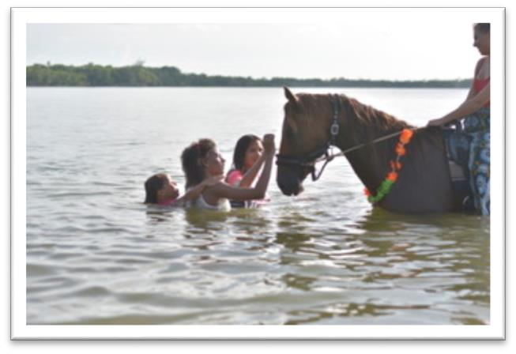
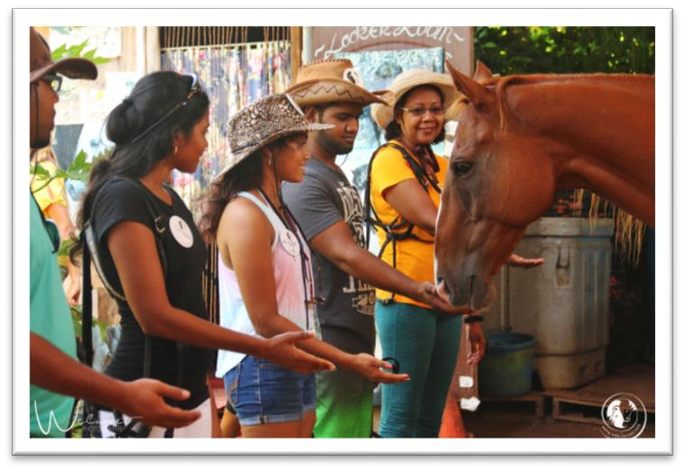
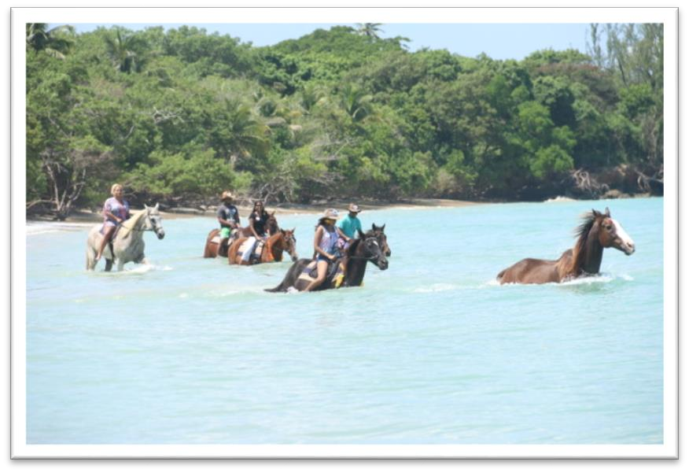
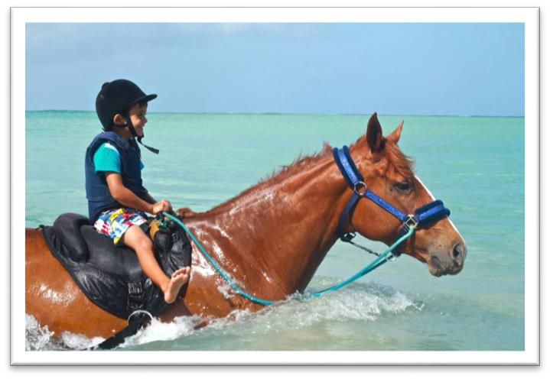
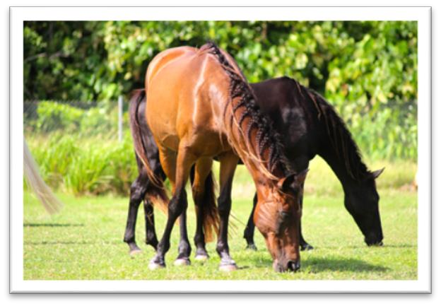
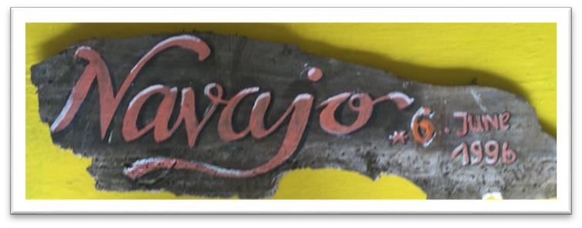

18

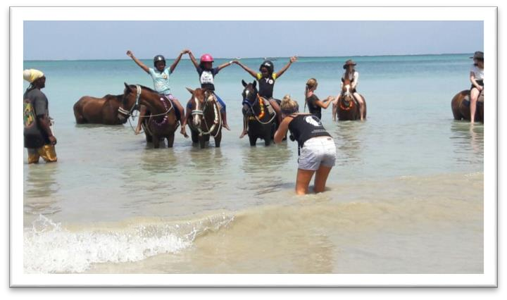
Challenges and Risks

Although equine therapy is not new to many countries in the world, on our tiny island in the West Indies most have never seen a horse nor had any exposure to being with these amazing animals as a therapeutic modality. Our programs have shown great success over the years. We are on the right track and have learned how to work with our community in presenting a program which at the start was difficult for many to accept. People were afraid, doubted our abilities and most certainly did not trust our gentle
giants to be friendly. With time, patience, endless invites, visiting schools for the differently abled, villagers seeing our horses walk through their village, swim in their bay and accept all who came to visit, we slowly gained the trust and confidence we needed to implement our programs.

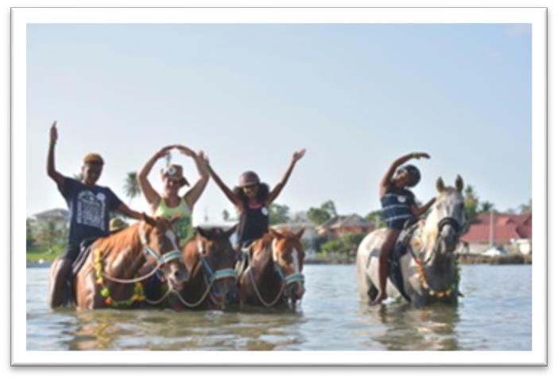
If we heard of a horse abandoned in a lone field we went, on foot, and walked endless miles to bring her to the stable as horse vans do not exist here. Undaunted by lack of feed we cut our own hay by hand, often traveling miles when dry season leaves us few options. We devise healthful blends of feed using coconut and molasses, gathering fruit and palm leaves assuring our herd
has the best of care we can offer regardless of weather or lack of vehicles. Water is trucked in, buckets are carried where needed.
Most of our herd came to us malnourished, injured, abused, neglected. Within weeks and without the aid of vets or "equine specialists" our treatment of daily sea baths, massages, clean feed from nature's bounty, and always in company of each other, our lonely orphans blossom into vibrant, shining, muscled, calm, trusting members of a happy herd. Operating from a premise that if our horses, in spite of their backgrounds, health issues and prior conditions, are well nourished physically and emotionally, treated with respect and without the use of any forceful tactics either in manoeuvres or
harsh equipment (bits, bridles, spurs, ill fitting saddles, whips, martingales,etc) they will transfer their calm, trusting, gentle manners to our participants, visitors, and volunteers creating a new level of relationship. Children and adults with Autism, Down's Syndrome, Visual and hearing impairments, emotional trauma, grief, loss, cerebral palsy, etc. have made remarkable improvement not only in their physical abilities but discovered a place where they can trust, bond develop self confidence fully accepted, unjudged and loved by their four legged friends.

The main strain on Healing with Horses financially is assuring sufficient care for the herd. Feed, medicine, equipment, shelter, hygiene, hoof care, arena footing, tools etc.
If funding for their proper care is in place we can then employ monies raised to expand our programs, upgrade our facilities both for the participants and our beloved herd.
We are not presenting a dramatic change as we know our methods work. We are however, wanting to assure the care of our herd which is and always has been, our primary concern and the foundation from which we operate.

19

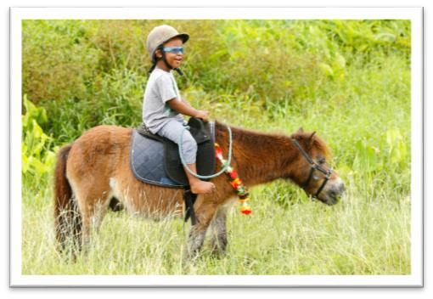
The HWH Foundation foresees very little risk of funds or innovations. We consider our projects low risk as we have always, and will continue to proceed with utmost caution and care taking on only what we know we are capable of in management of the herd, participants, park and volunteers. Although always striving to improve and implement new ideas as we grow and learn, we are detail oriented in every area of the organization. It is imperative that the care of our horses be of the utmost quality and focus applied at all times to insure the well-being and safety of all. With proper maintenance of our horse park, fencing, safety equipment, arena, fencing, and experienced staff we can assure the best possible environment and the ability to open our programs to a larger portion of the population.

Our accounting is impeccably maintained with professional accountants and fully transparent, open to audit. All monies spent are carefully recorded, receipts filed and accessible. Access to the funds is secure.

Thank you Marjorie Linglet ( HWH International Liason ) for this amazing write up about HWH

How can you help? As a Volunteer
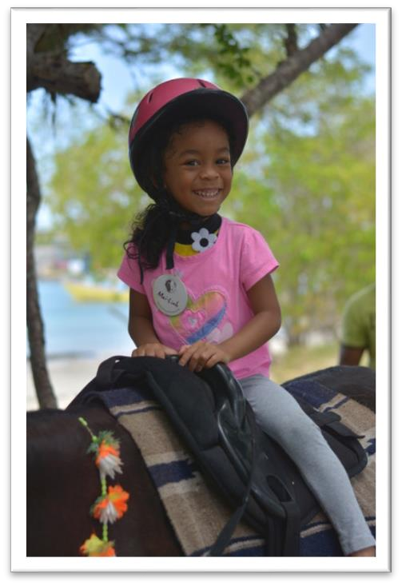
If you‘re willing to spend some time working with horses and differently abled participants our afterschool sessions are for you! We can provide the necessary hands-on training you need to work with the horses and participants.

If you are a professional, especially in areas of therapy (e.g. ABA therapy, physiotherapy, speech therapy), horses (equinology, equine vet, trainer, fairer), fundraising, IT, event planning, video and photography we would much appreciate your skills.

If you do better in-doors, the office environment maybe for you. We’ll train you in our daily operations such as answering the phone, scheduling sessions and selling memorabilia from the Love and Magic Centre.

As a Donor or Sponsor
We accept In-Kind donations and money to assist us in our programmes, daily activities, equipment and improving infrastructure. We can provide businesses and organisations with a receipt of the donation, pictures of beneficiaries and or improvements for their use.

If you wish to know what items we need ask for our Wish List.

Follow this link to find out more http://www.healing-with-horses.org/initiatives/become-a-supporter.

20

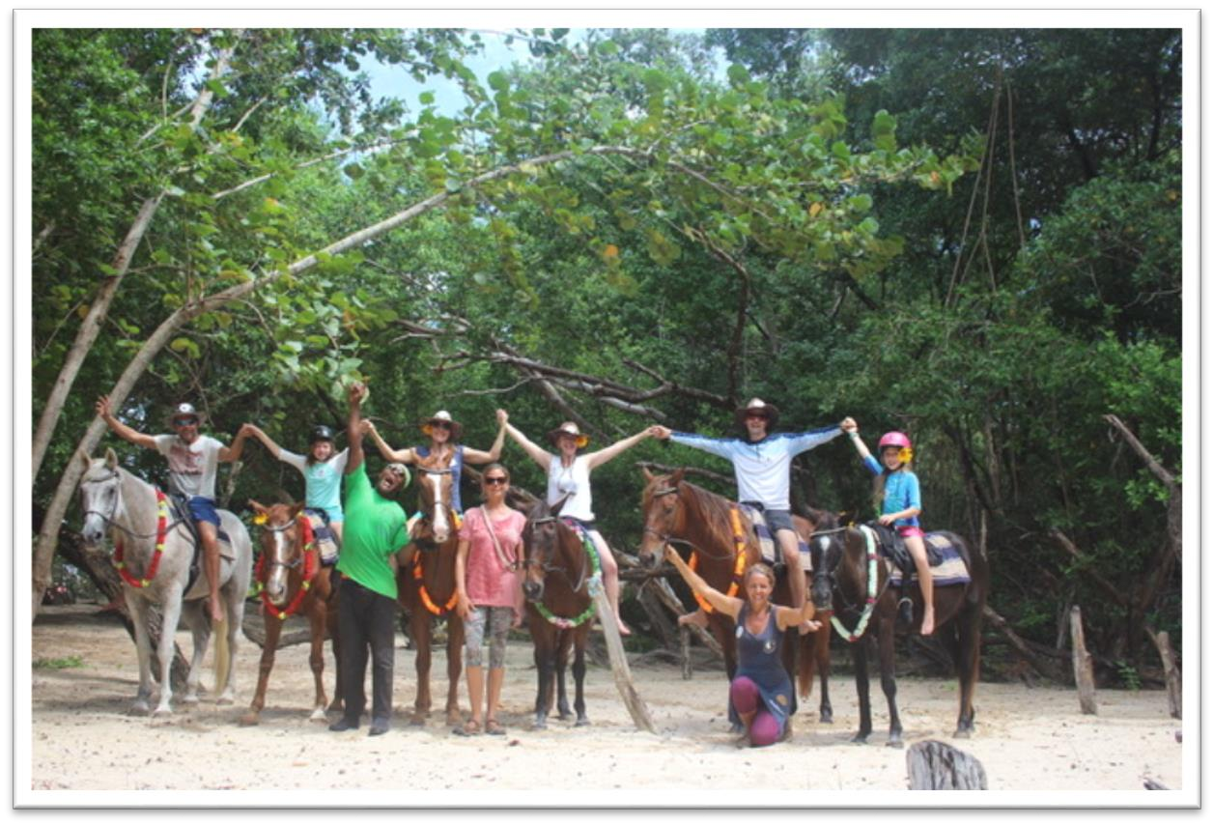
Future Plans
❖We will cover the Riding Ring at the HWH Park
❖Obtain funding for a mini bus to pick-up and drop-off children to and from sessions. ❖Maintain or replace existing structures (e.g. tents).
❖Improve the HWH Park and setting up a new location for a retreat for HWH Herdmembers. ❖Building Washroom Facility at the HWH Park in Buccoo Point
❖Continue the development of the organisation.

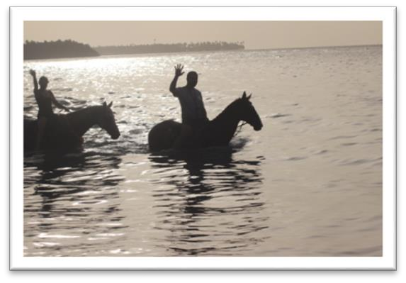
For Additional Reading
For more information on this foundation please read the following documents:

❖ “Healing with Horses Annual Plan & Calendar of Events 2017”
❖“Summer Camp Proposal 2017” please follow this link http://healing-with-horses.org/initiatives/integrated-summer-camps

21

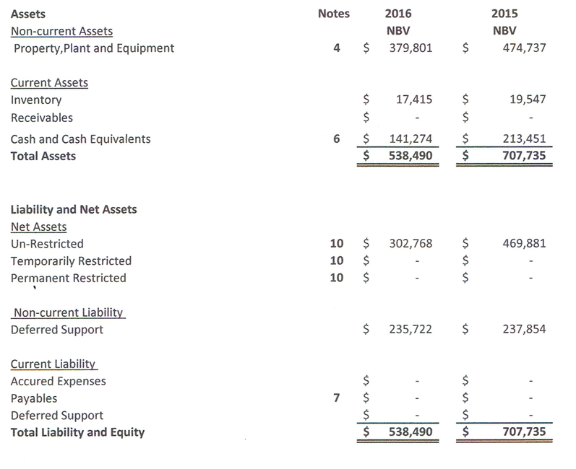
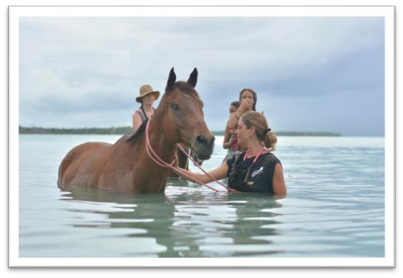
Financial Statements 2017
Statement of Financial Position for the year ended 31st December

22

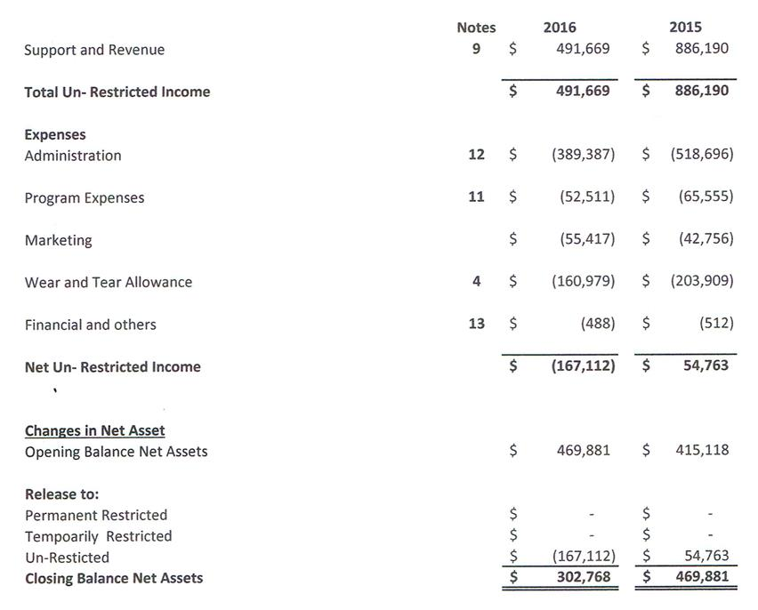
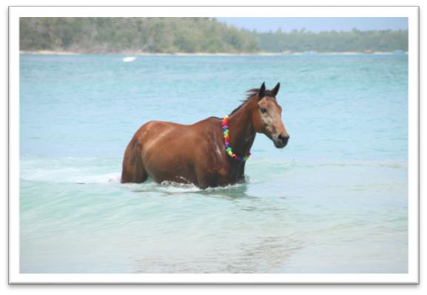

Statement of Activities and Changer in Net assets for the year ended 31st December 2016

23

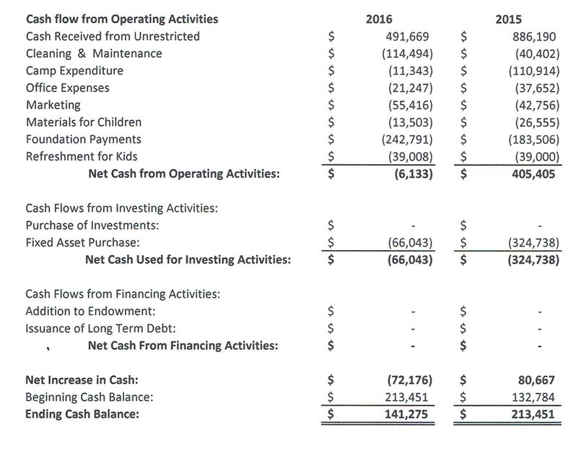
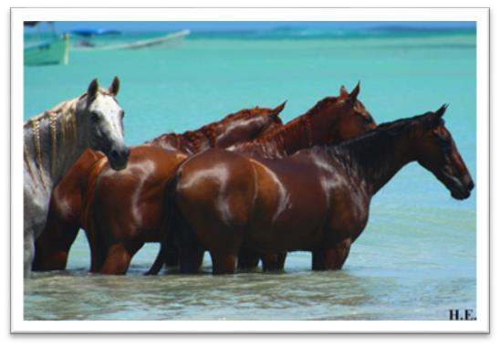
Statement of Cash Flow for the year ended 31st December 2016

24

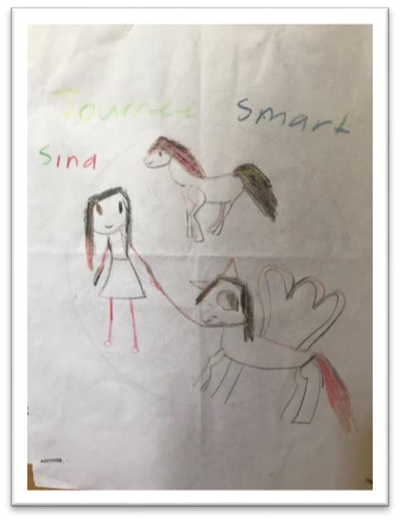
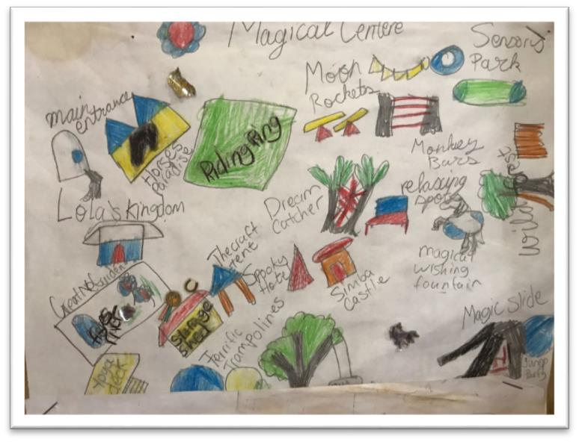
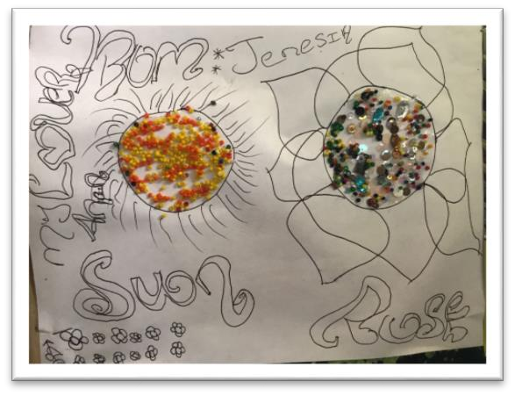
Addendum A
Timetable for Ongoing After School Sessions Supported by Kristy Leber (BWH Hostess)

Wednesdays
1:00pm-2:30pm: Differently abled elderlies from The Technical Vocational Centre - Being with Horses sessions

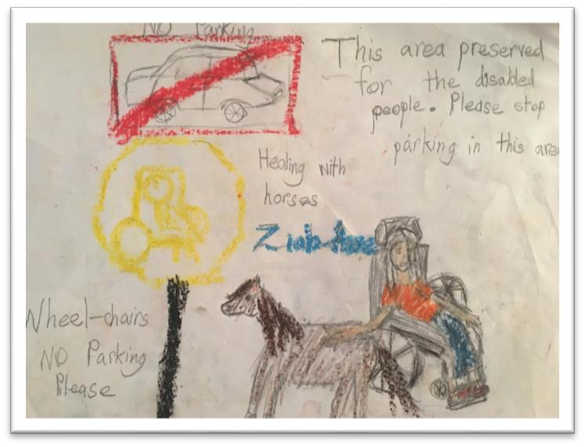
Fridays
3:00pm-5:00pm: Children from the Yahweh Foundation
- Being with Horses sessions

25

Addendum B

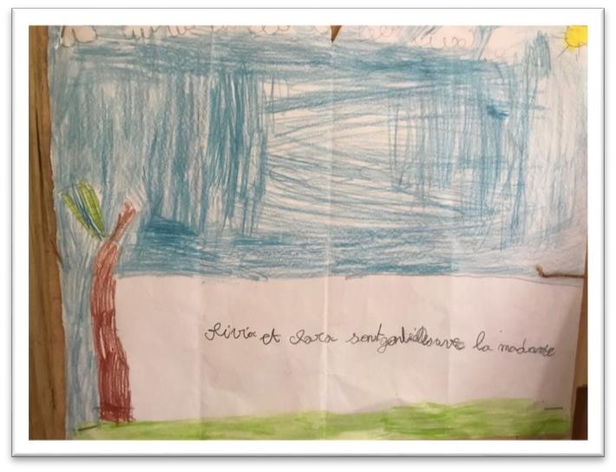
Calendar of Events 2016 September 2016
❖Ongoing Afterschool sessions

October 2016
❖Ongoing Afterschool sessions
❖4th to 20th November - Sina Reichenbach volunteered at HWH
❖10th - HWH participated in Buccoo Heritage Day
❖15th - HWH had a tent at the Maritime Financial Run for Fun 5K & Charity Fair event in Nelson Mandela Park in St. James, Trinidad
❖15th - Elspeth Duncan resigned from the HWH Board
❖16th - Healing Ring of Tantra meditation circle at the Healing with Horses Park ❖25th - Christine Peiser, HWH Office Assistant resigned
❖30th - Diwali Celebration

November 2016
❖Ongoing Afterschool sessions
❖1st Juergen Rauch officially started as Park Manager
❖05th - Sugarfingers HWH fundraiser at the Magdalena Grand Beach & Golf Resort ❖14th - Thou Art Yoga's Healing Ring meditation at HWH Park
❖20th - A visit from representatives of Edition Boisélle

December 2016
❖Ongoing Afterschool sessions
❖SPECIAL Discovery Days and Family time at the Healing with Horses Nature Sanctuary at Buccoo Point (throughout the month)
❖3rd - HWH participated in Guardian Group's annual Shine 5k Run ❖12th - HWH Pool Lime at the Magdalena Grand Beach & Golf Resort

January 2017
❖Ongoing Afterschool sessions
❖15th to 28th February - Katarzyna Rozanska worked as HWH Office Manager ❖30th - Jessica Alfred, HWH Paddock Manager resigned

26

February 2017
❖Ongoing Afterschool sessions
❖12th - HWH participated in Peace Walk in Buccoo

March 2017
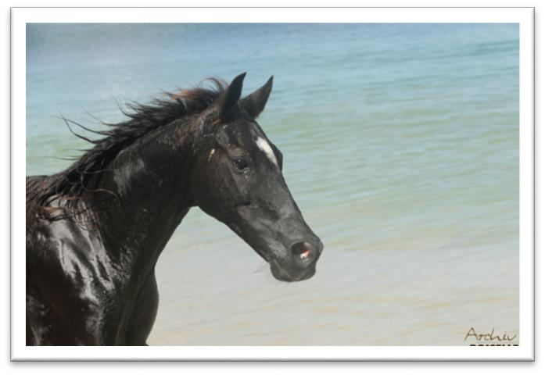
❖Ongoing Afterschool sessions ❖1st to 30th April - Shenelle
George volunteered as Office Assistant
❖4th - Aberdeen joined the herd ❖7th - A visit from
representatives of Access Consciousness
❖9th - Usha Persad resigned from the HWH Board
❖15th - Ms. Monica Babb resigned from the HWH Board

April 2017
❖Ongoing Afterschool sessions
❖Mr. Jayon Brathwaite, the first differently abled OJT of Trinidad and Tobago started working at HWH Park
❖5th - HWH officially welcomed Dr. Leah Pouchet and Mr. Arendell Brewster to the HWH Board at the monthly board meeting
❖08th - Daily Express published a feature article about HWH, written by Kimberly Wallace ❖18th - HWH Participated in the Annual Buccoo Easter Parade
❖20th & 21st - TTouch clinic held by Ingrid Wild from Germany; www.wild-pferd.com ❖26th - Channel 5 interviewed the differently abled adults working at the HWH Park ❖27th - Omadara Mills of the THA’s Division of Community Development and Culture
interviewed the differently abled adults working on the grounds and supporting HWH ❖28th - Ms. Sharshel Balfour started working in the HWH office

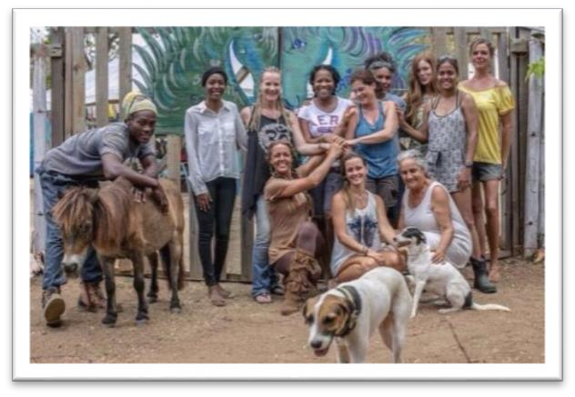
May 2017
❖Ongoing Afterschool sessions ❖01st to 10th – Animal Communication
Workshop held by Anna Twinney (Reach out to Horses) from USA/ England
❖1st to 31st - Sharshel Balfour worked as HWH Office Manager
❖ 19th - A visit from a representative of the United Nations

27

❖25th to 22nd August, Noel Juarez Ramirez (Mexican) and Sandra Hertz (German) volunteered at HWH
June 2017
❖Ongoing Afterschool sessions
❖18th - HWH participated in the Ah Tribute to All Fathers Event at the Integrated Bucco Facility
❖21st - Summer solstice celebration with the TecVoc students sponsored by ThouArtYoga at HWH Park
❖24th - A visit from a representative of the JB Fernandes Trust, Ms. Inca Mohamed ❖25th - General Camp Meeting with Community members and staff
❖26th - Ms. Sarah Vilain started as HWH Office Manager/Administrator
❖27th to 28th September Anna-Marie Pillai worked as HWH Camp/Volunteer Coordinator ❖27th to 1st August - Laura Conigiello volunteered at HWH
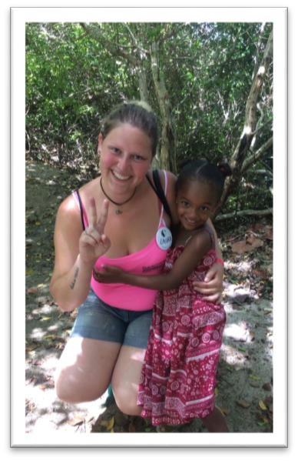
❖28th - Representatives of the Maritime Financial Group participated in the weekly HWH session with the students of Tobago’s Technical Vocational Centre

July 2017
❖7th - Radio Interview with 103 FM Staycation Program ❖10th to 28th - The 7thAnnual HWH Buccoo Integrated
Summer Camp
❖28th - An Appreciation ceremony for the Campers, Volunteers and staff of HWH Summer Camp
❖29th - Mr. Ronaldo Cooper began volunteering at HWH, on the recommendation of Mr. Quami Gordon of the Trinidad and Tobago Probation Services

August 2017
❖August 01st to September 15th - The Healing with Horses Park opened to the public
❖1st - A visit from Atiba Antoine and Francine Look-Hong, the directors of PlayAble ❖12th - Yard Sale at the HWH Love & Magic Center
❖20th - A visit from The Honourable Dr. Keith Rowley, Prime Minister of Trinidad and Tobago
❖29th August to 15th September - Noema Mahler Volunteered at HWH

28

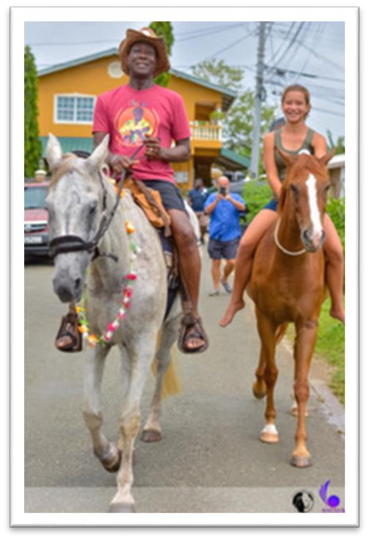
September 2017
❖ Ongoing Afterschool sessions
❖ 4th - Timothy Marshall began volunteering at HWH, on the recommendation of Mr. Quami Gordon of the Trinidad and Tobago Probation Services
❖ 16th - A visit from Assemblyman Jomo Pitt, Secretary of Sports and Youth Affairs
❖ 23th - Special Screening of Dream: A Short Film ❖ 30th - Chant & Pant Event at the HWH Park

October 2017
❖ 4th October - Lena Kayser began volunteering at HWH
❖ 11th - A visit from the Magdalena Grand Beach Resort Representative with the Tec Voc students and the HWH Volunteers at the HWH Park
❖ 14th – HWH participated in the Guardian Group’s Run For Fun Event at the Nelson Mandela Park in St. James, Trinidad
❖18th – Be the Light: HWH Diwali fundraiser concert held in the Buccoo Community Centre

29

Addendum C
In-Kind Donations September 2016 to September 2017

Date | Name | Donation
17 September 2016 | Mary George | 1 case of water & 1 case Gatorade
03 October 2016 | Bruce Campbell | Printer/Scanner &Printing Paper
19 November 2016 | Janet Wells | Silver Cream
19 November 2016 | Emanja Alleyne | Clothes
29 November 2016 | Terry Grant | 11 Teddy Bears
30 November 2016 | Satu Kärnä | 2 bottled of Silver Lotion
01 December 2016 | Terry Grant | 1 bag of Ladies Clothes
01 December 2016 | Line Dobrowen | Miscellaneous Items
01 December 2016 | Farfan | 1 gallon of paint
19 January 2017 | Tourist | 1 Child’s Bicycle
23 January 2017 | Tourist | Sports Equipment
28 January 2017 | Kristy Leber | Miscellaneous Items
25 February 2017 | K. Ballard | 1 Saddle
01 March 2017 | Mella Patterson | Kids Books & Toys
02 March 2017 | Astrid | Clothes & Small Items
03 March 2017 | Janet Wells | Stirrups
01 June 2017 | Susanne Hirschmann | Clothes
11 June 2017 | Hirschmann Family | Books
27 June 2017 | Hirschmann Family | Clothing & Books
28 June 2017 | McLetchie Family | 1 Blender
28 June 2017 | Maritime Foundation | Clothes
29 June 2017 | Marjorie Linglet | Kitchen appliances and utensils
01 July 2017 | Elspeth Duncan | 1 Mirror
01 July 2017 | Kristy Leber | Clothing
03 July 2017 | Marjorie Linglet | 1 Cutting board
05 July 2017 | Mr. Kern | Fruit &Vegetable scraps for the horses
05 July 2017 | McLetchie Family | 1 Case of Gatorade & 1 Case of Water
06 July 2017 | Marjorie Linglet | Kitchen Utensils
06 July 2017 | Wendy Yawching | Miscellaneous Items
11 July 2017 | Sophie Vestergaard Sørensen | 1 Helmet
13 July 2017 | Marjorie Linglet | Sewing tools & 1 bucket of Mangoes
14 July 2017 | Jackie Armstrong | Horseshoes & Miscellaneous
19 July 2017 | Michelle Knott | 3 Cases of water, 2 Cases of Orchard juice, 4 packs of forks, and 1 pack of napkins
20 July 2017 | Danielle Bynoe | Food stuff

30

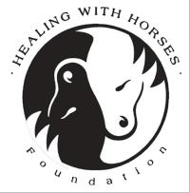
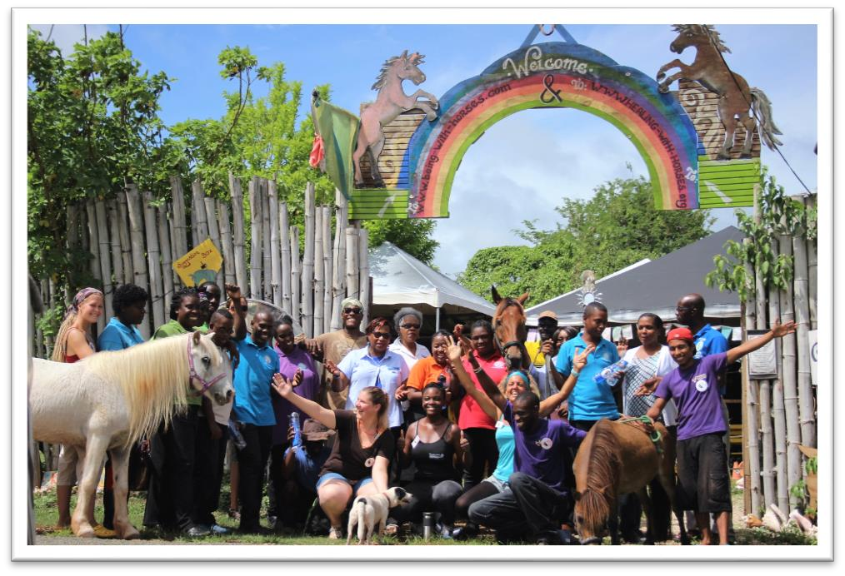
20 July 2017 | Michelle Knott | Clothing
21 July 2017 | Simone Ferreria | Miscellaneous Items
24 July 2017 | Fie Jørgensen | Toys
25 July 2017 | Simone Ferreria | 2 Rugs & 1 Whiteboard
25 July 2017 | Marjorie Linglet | Bucket of mangoes
28 July 2017 | Carmen Danzer | 1 Dish rack
31 July 2017 | Inken Janning | Toys
07 August 2017 | Lena Dempewolf | 1 inflatable Swimming pool
09 August 2017 | Mr. Kern | Watermelon for horses
07 August 2017 | Rachel Winter Roach | Miscellaneous Items
29 August 2017 | Simone Ferreria | Miscellaneous Items
09 September 2017 | Mary George | Toilet paper
30 September 2017 | Supermarket at Colosseum | Food Stuff
30 September 2017 | Usha Persad | Clothing
02 October 2017 | Terry Grant | Clothing
15 October 2017 | Luisa Fernandes | 1 Leather Saddle
15 October 2017 | Debbie Thompson | 1 Synthetic Wintec Saddle

31

